## 1.About my project

The project is divided into server side and client side.

Both server and client use Java.

I build the client in android studio IDE 3.3. (minSdkVersion 24, targetSdkVersion 28)

And the server is built in netbeans IDE 8.2 (Using SQL SERVERL database)

## 2.The function of my app

If someone wants someone else to help him get or send something(such as take-out food, express …)or run errands for tips , he can use this app.

you can login in this interface: or sign up:

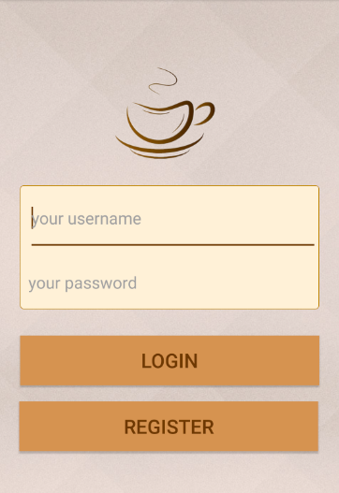 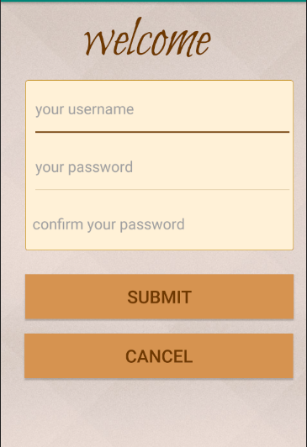

Modify your personal information Create a new order and wait for someone else

so that others can find you: to get it

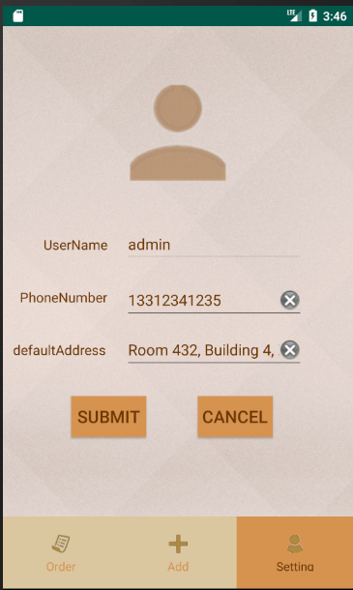 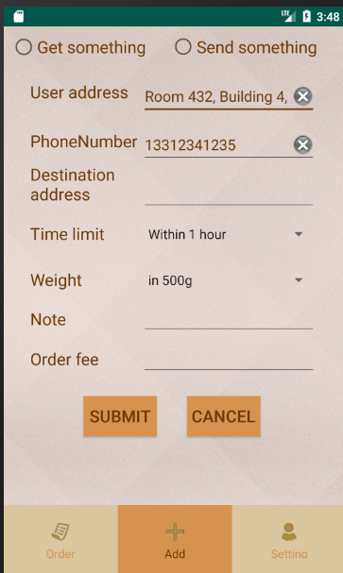

In this interface, you can view the orders you create, the orders others post online, and the orders you get for tipping.

